**Project Development Phase**

| **Date** | **12 November 2022** |
| --- | --- |
| **Team ID** | **PNT2022TMID16827** |
| **Project name** | **Project – Visualizing and Predicting Heart Diseases with an Interactive Dashboard** |





**Sprint-4**

**Report Generation**-Make the dashboard convert to Report that can be

useful for the User.

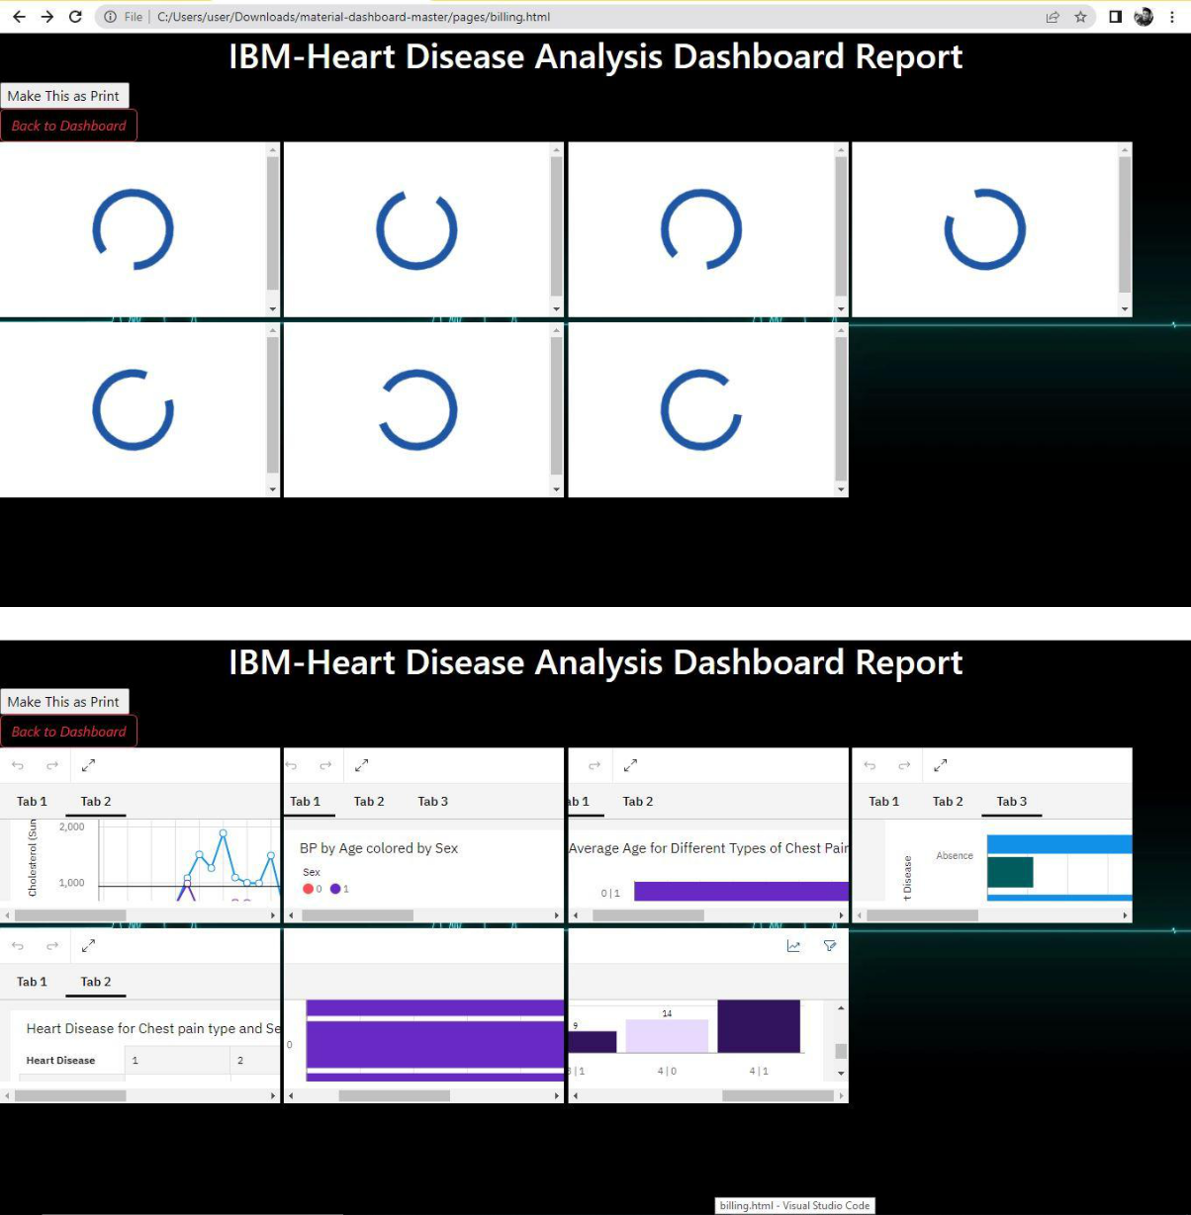

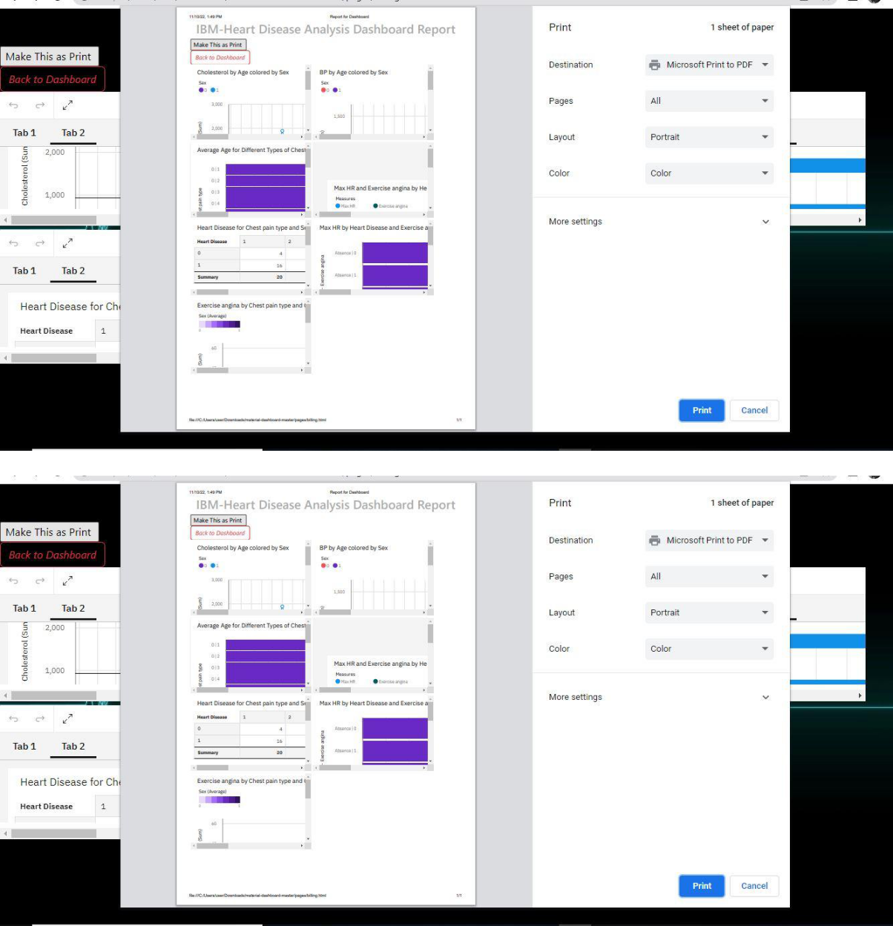

Data Visualization:





